8/30/2022

Mortgage Calculator



Carl M

Appwrk.com

Contents

**Introduction** 2

**Objectives** 4

**Mission** 5

**Problem Faced** 6

**Solution Proposed** 6

**Roles and Prospect Users** 7

1. Admin Interface 7

a. Admin Login Cred 7

2. End User 11

a. Customer Login Cred. 12

**List of Steps and Technology stack used** 16

Step 1: Install PHP 16

Step 2: Download Opencart4.0.0 18

Step 3: Installation of the OpenCart into Xampp 20

**Things to remember after OpenCart theme installation** 24

# **Introduction**

Mortgage Calculator is the best Online Calculator to check the EMI of the loan amount. All banks provide different types of loan like home loan, car loan, study loan etc. they have set the amount to be paid on the behalf of Interest rate and time duration. According to the time duration and rate of interest they have set the amount on the behalf of Mortgage formula.

They need to find the EMI in the monthly instalment to pay. Whenever any of the person apply for the loan from the bank or other financial organization, they need to calculate the EMI and total amount to be paid so thus they can find the total interest how much they need to pay. Sometime the person like to pay some part of the payment as a down payment so in this case the interest will be applicable on the rest of the amount and calculate the interest or EMI on the behalf of pending amount.

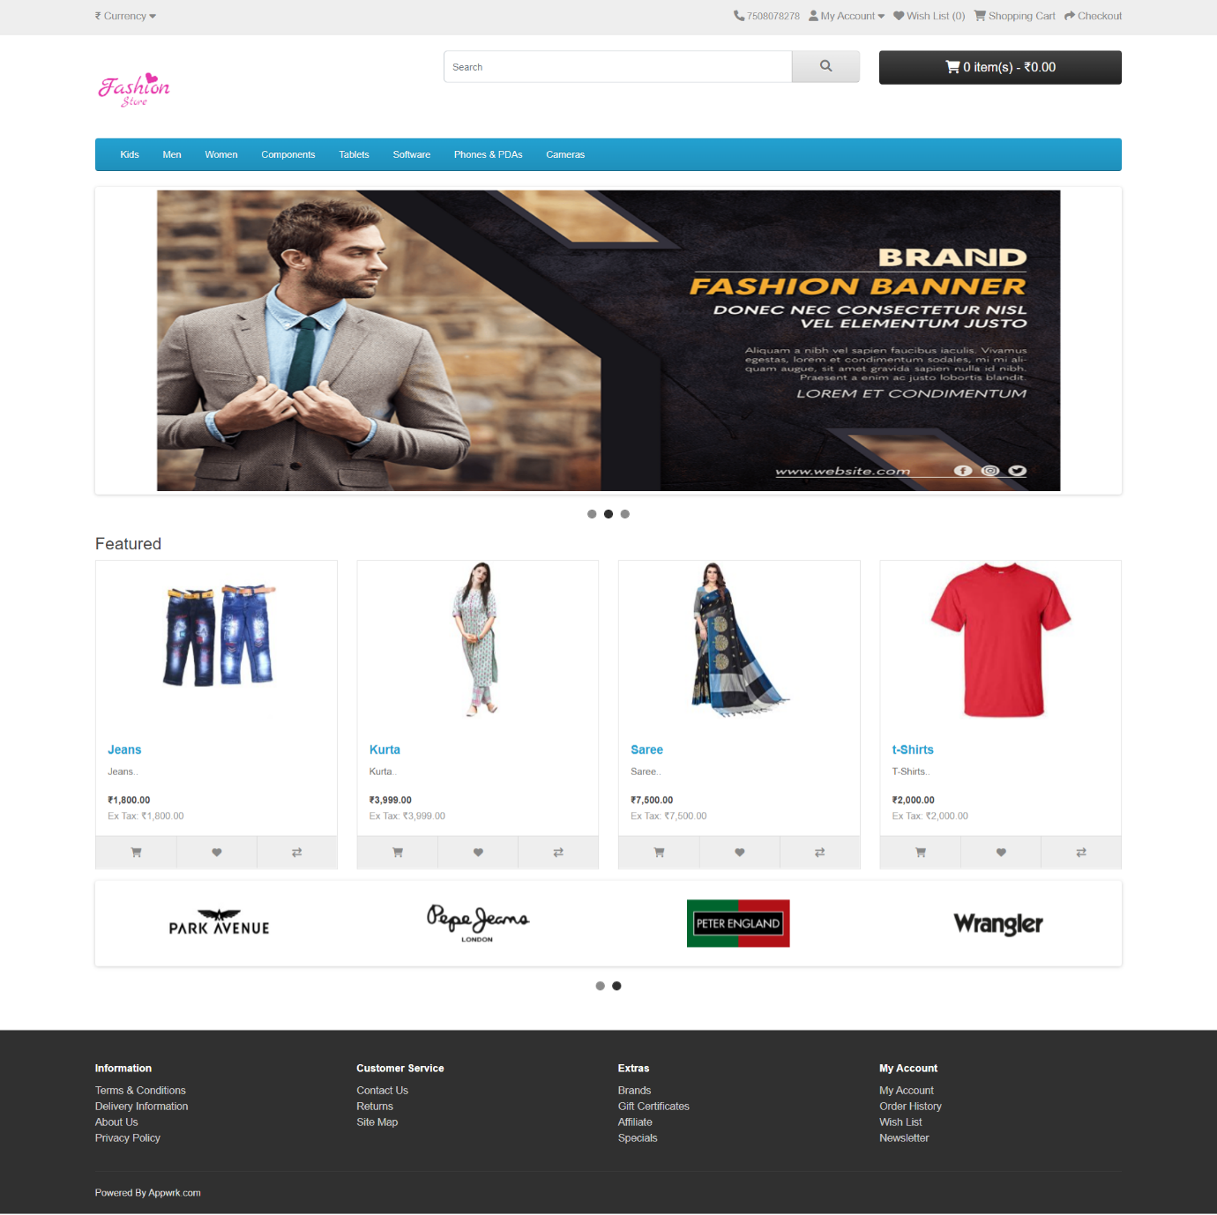

# **Objectives**

* We can easily calculate the EMI of the Loan amount.
* No need to add the down payment for the Calculation
* End-user need to add his Basic Details like Name, Email, Mobile No.
* End-user can view the record into the Yearly and Monthly graph to view the details of instalment.
* After following all option End-user can easily take the printout of instalment report.

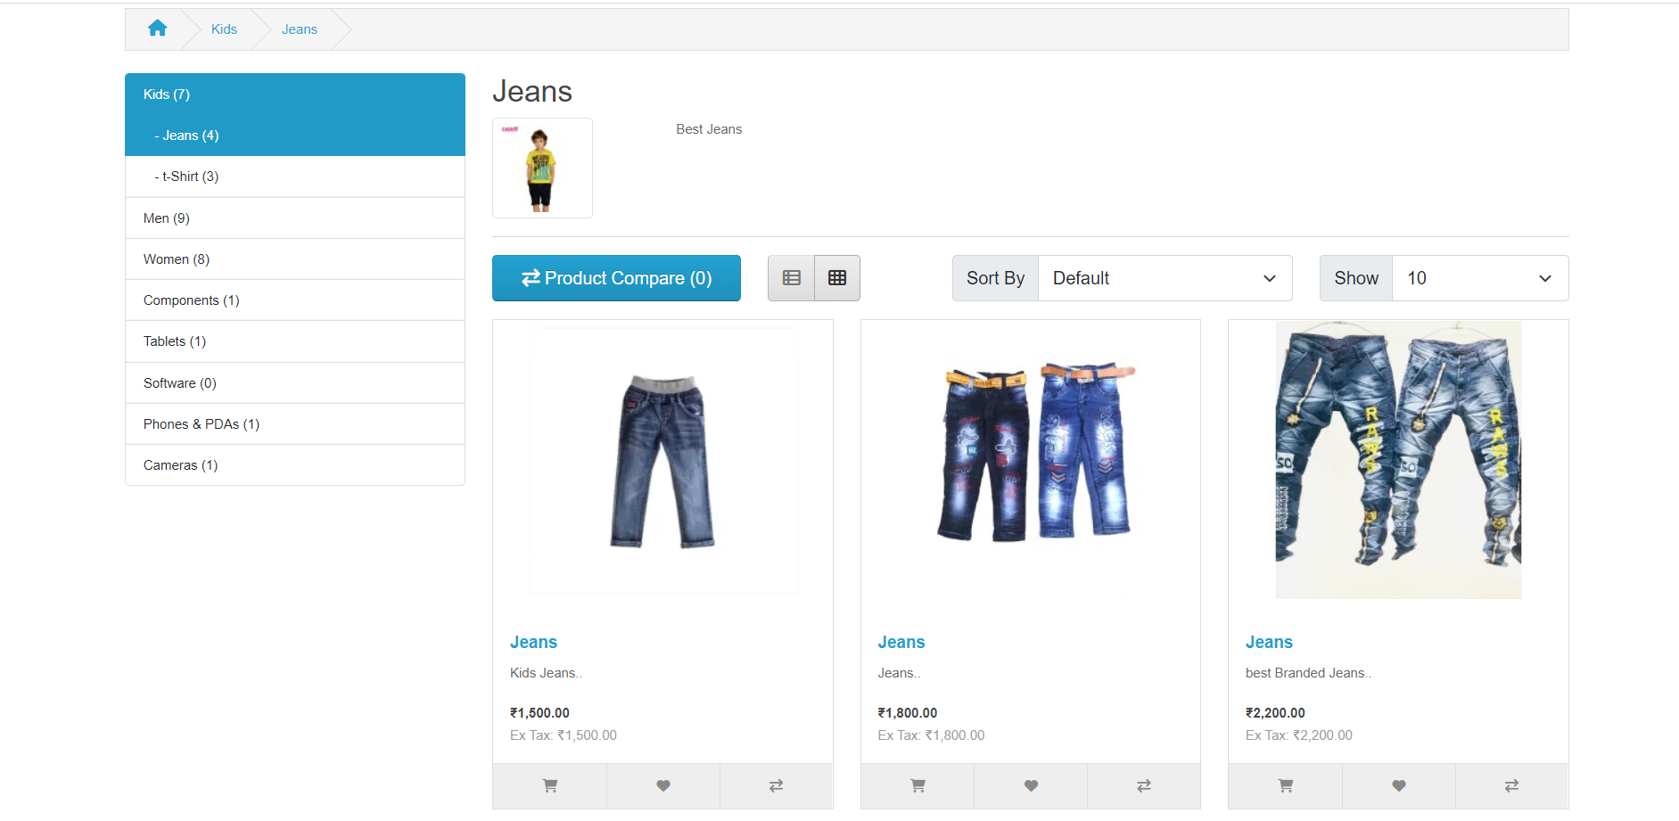

# **Mission**

Our Main target is to develop a product which would be helpful for the Financial Organization or Normal User who can easily calculate the EMI and Total Amount how much they need to pay after getting the loan from the Bank or Financial Organization. All these things are very important. They can easily access this **website** without any calculation. They just need to enter the few basic details after that they can easily use this website to get the details of payment.

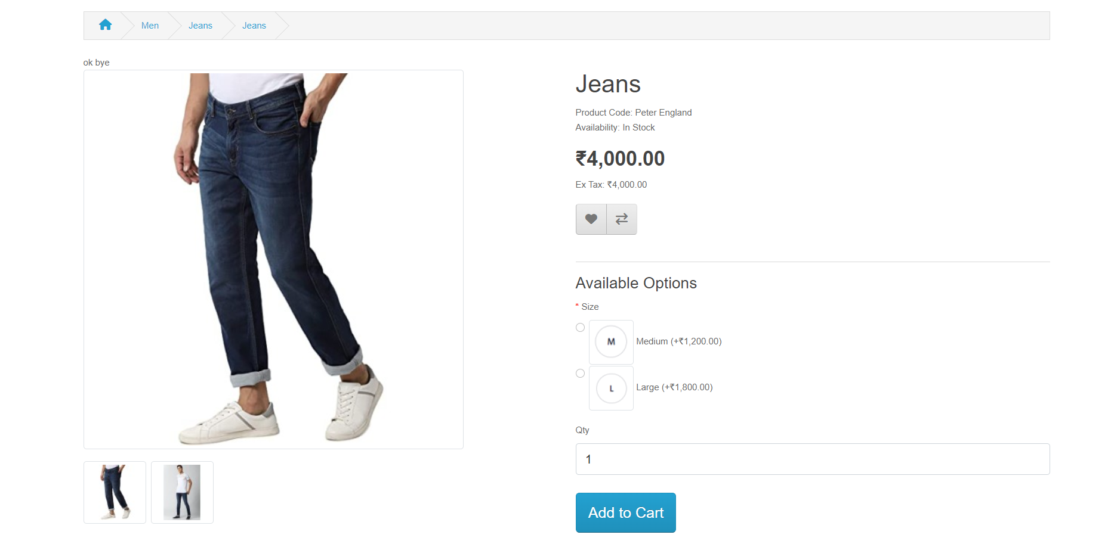

# **Problem Faced**

1. When, I have started the working on Installation of the OpenCart which is very popular CMS but here we must need to check the Installation version so thus later on we can use the relevant themes and Extensions which must be compatible with the OpenCart otherwise we will get the error and sometime the app will crashed on live server.
2. I have used the latest version of the **OpenCart 4.0.0 and PHP 8.1**. on Live and local Server.
3. Whenever I have tried to install **OpenCart4.0.0 on PHP 7.9** then I will get the error related to the PHP version.

# **Solution Proposed**

1. For the above problem solution, I have download and install the Latest version of the **PHP8.1 and MySQL 8.0 with Apache** so thus I can easily install the OpenCart on the System.
2. After the Installation, here I need to download the **OpenCart4.0.0** version tool from the online site.
3. For any of the alteration, we need to login to admin portal of the site so thus we can add products and if like to make any changes in the layout then also need to get the help of the admin section.

# **Roles and Prospect Users**

## Admin Interface

* The main Target of this web-portal to provide a complete control panel to the client or business organization to handle the data of the store like categories, products, images and prices etc.
* Admin has the rights to manage the products, images, prices, and also can add discounts etc.
* Without any training admin can easily add category, and Products which is very useful for them to manage the working of the store.
* Owner can easily view the list of orders which is very important to check the demand and traffic over the site etc.

### Admin Login Cred

**URL:** <http://fashionstore.appwrk.com/admin/>

|  |  |
| --- | --- |
| User Name | Password |
| Admin | Admin@123456 |

1. With the help of the above link we can directly move to the admin login web page from where only admin can login with the help of correct User Name and Password

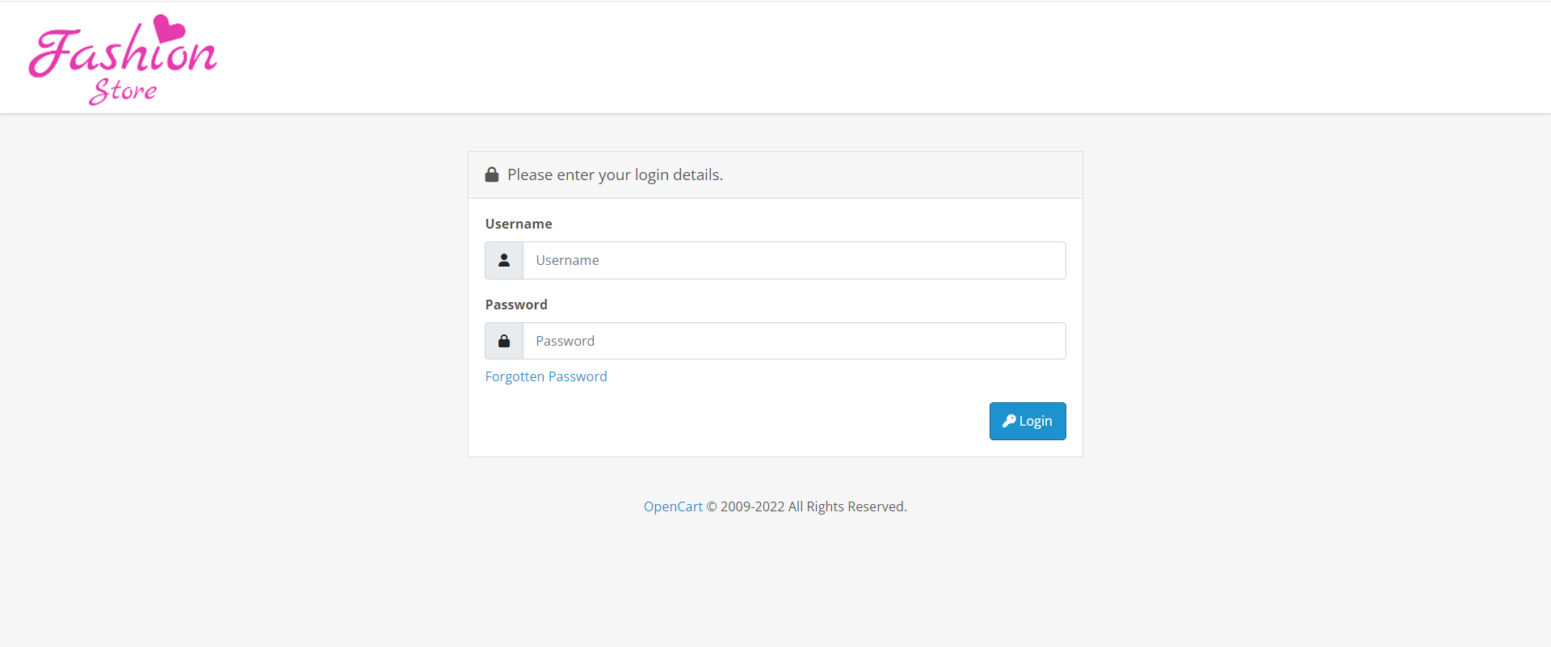

1. When the admin fills the correct **user’s name and password** then he can directly move to the admin Dashboard which is also known as control panel.

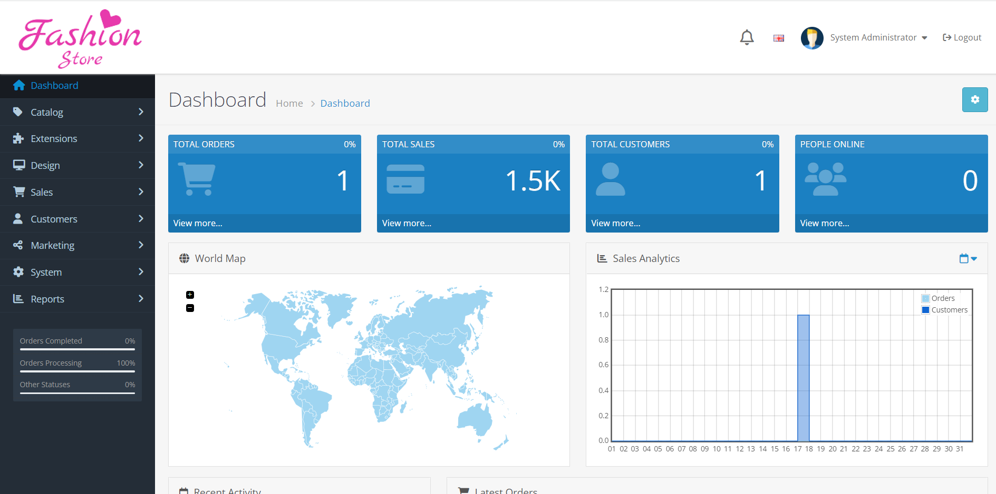

1. To add New Category or Product then we must need to click on the left hand-side menu which can from there need to **click on catalog>> then need to select the Category,** when we want to add New Category then need to click on the **Right-Side blue Button**

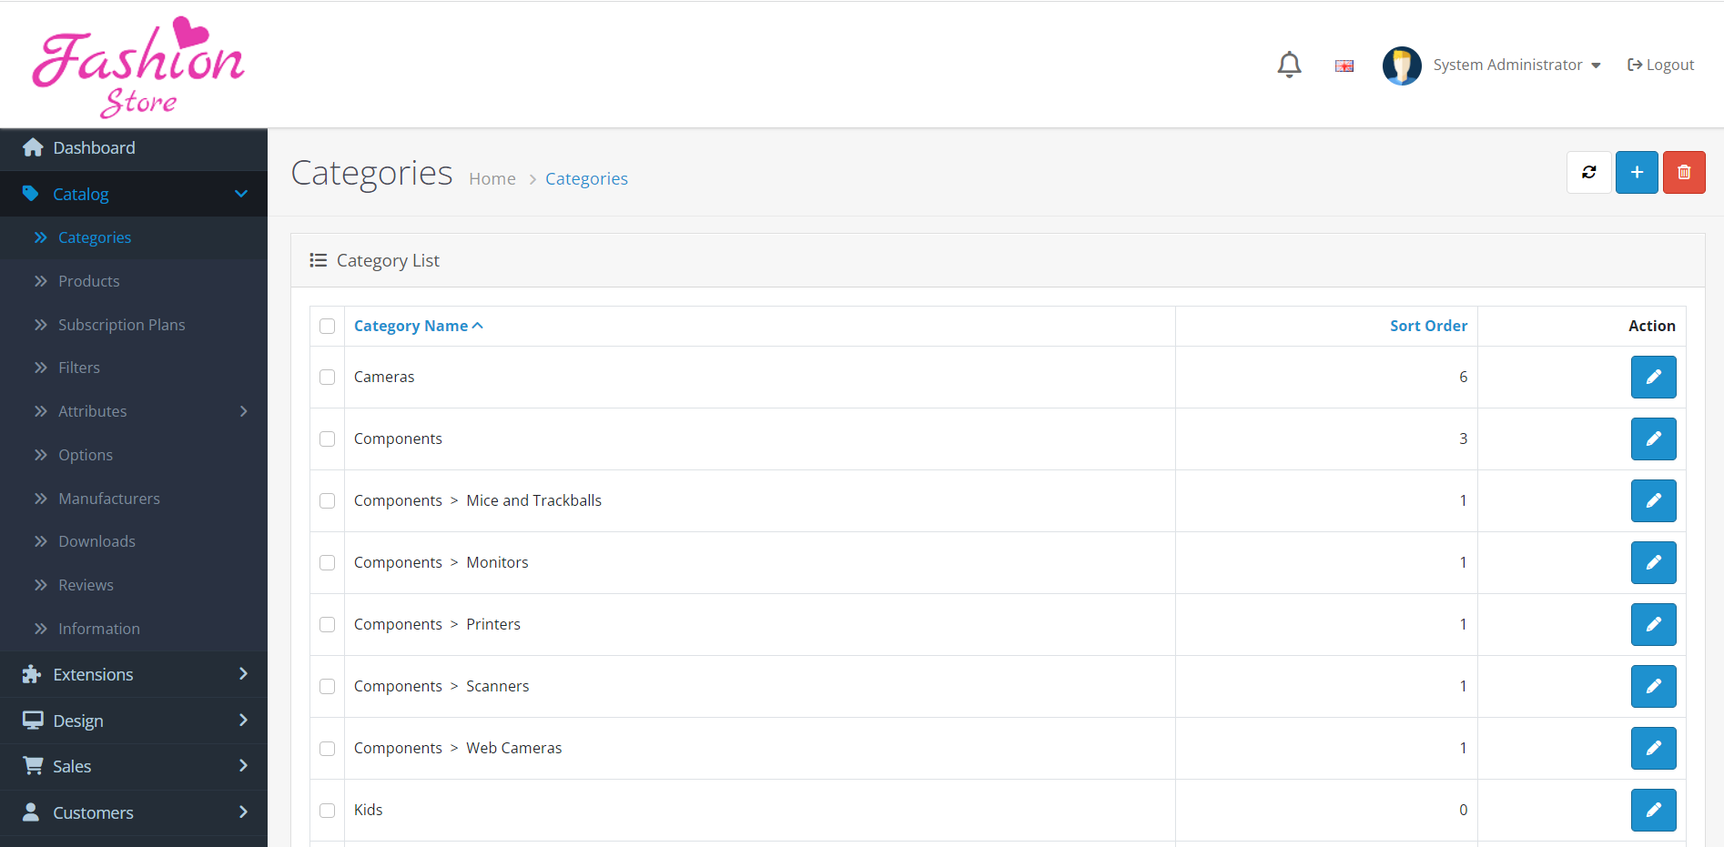

1. Here we can see the list of Category, when we need to add new Category then need to click on the blue button on the **Right-hand side upper side** then a new box will be visible to add **new category.**

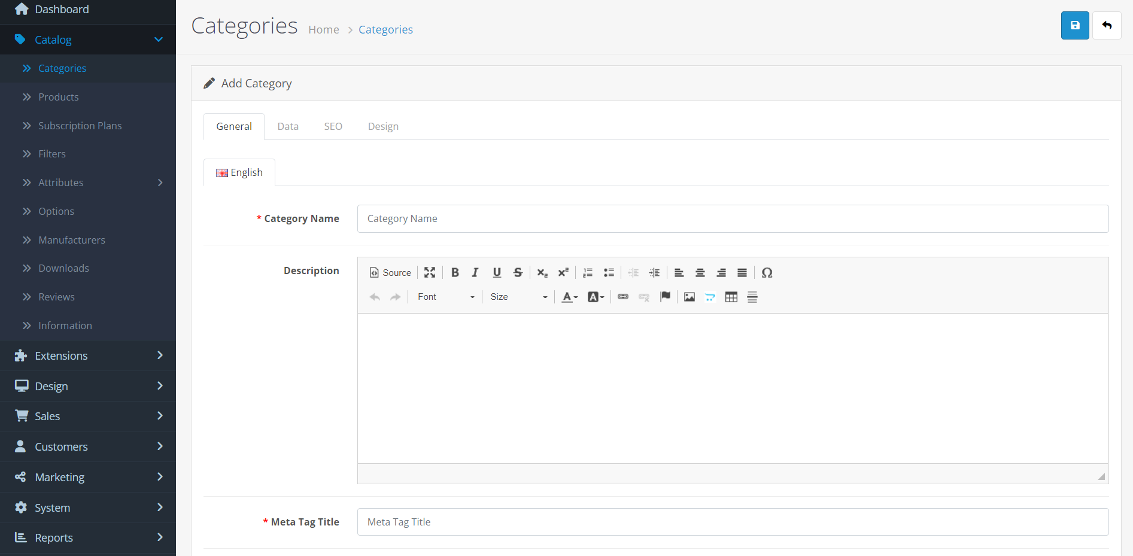

1. When we want to add Product under the category then we need to click on the Add Product but and new page will be visible and need to click on the **(+)** to add New Product from the Upper right Corner.

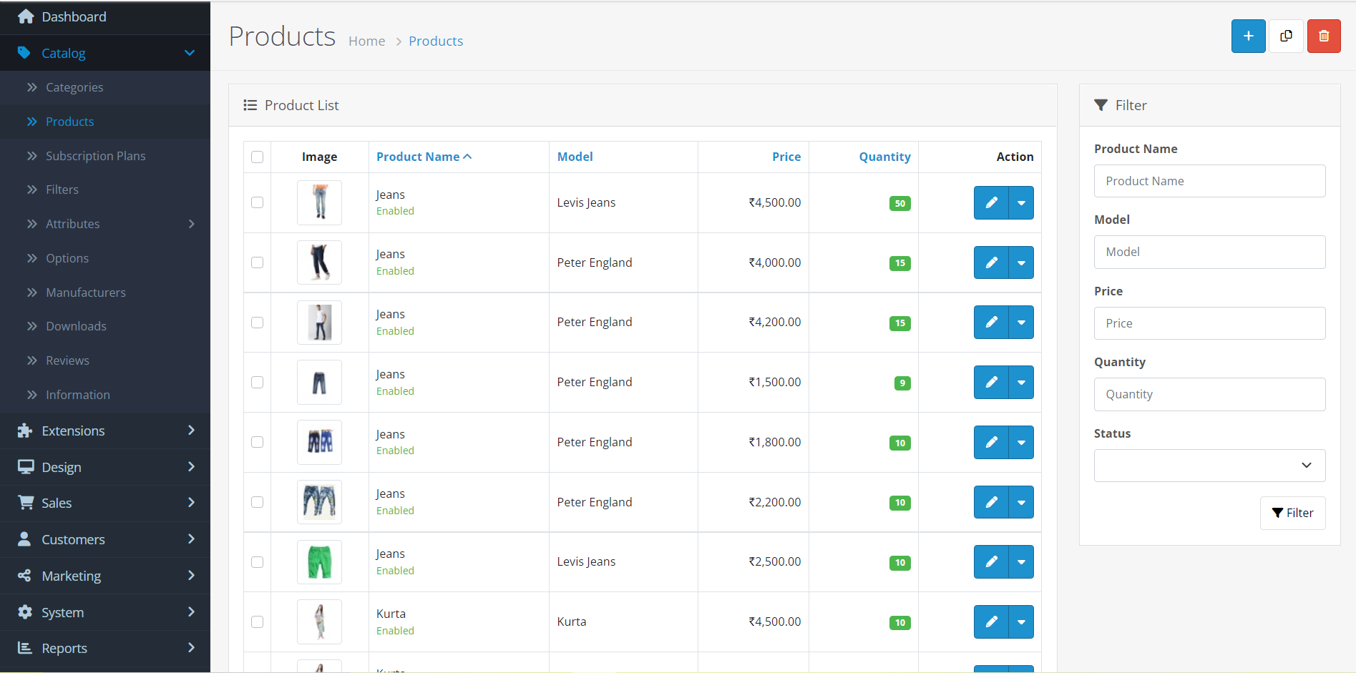

1. After filling the details of the product, we can easily check the product is visible on web portal. Here we can see that under the Product tab we have list of features like Discount, Attributes, options, Images etc. after that we need to click on save button.

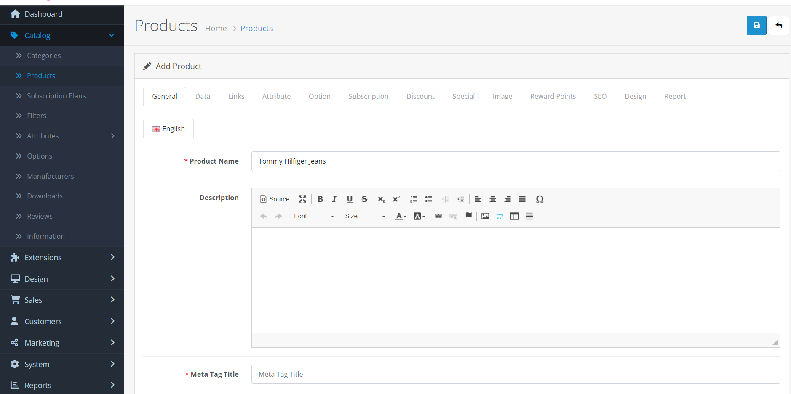

1. After that we can easily view the list of products under the admin section for the verification.

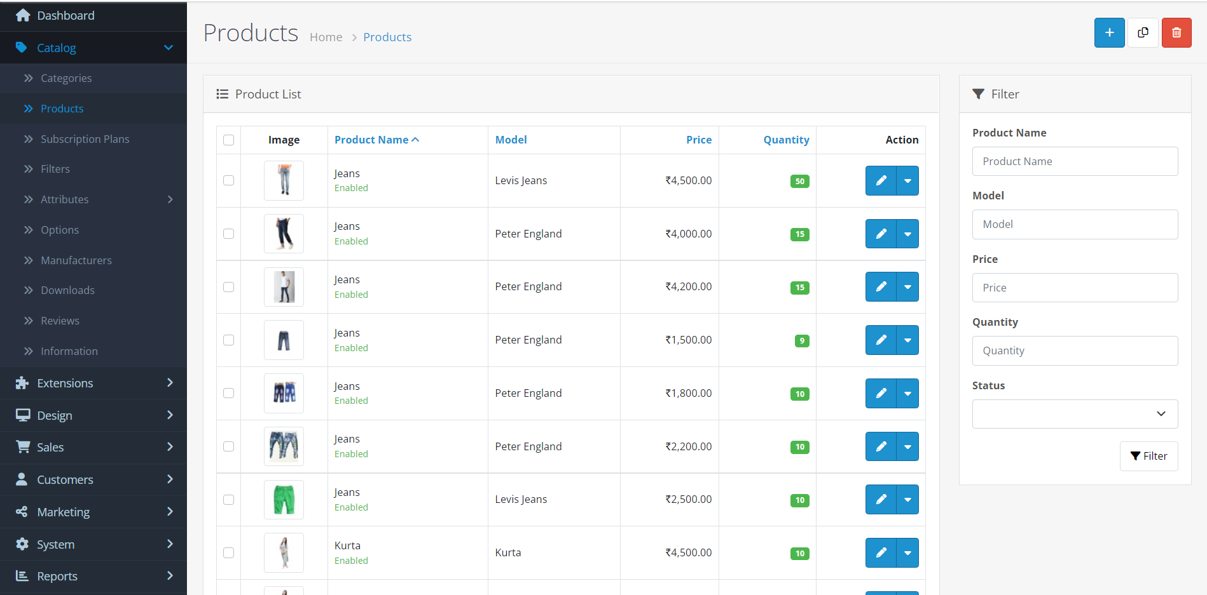

1. After saving the image of the new products we can view the product into the category section.

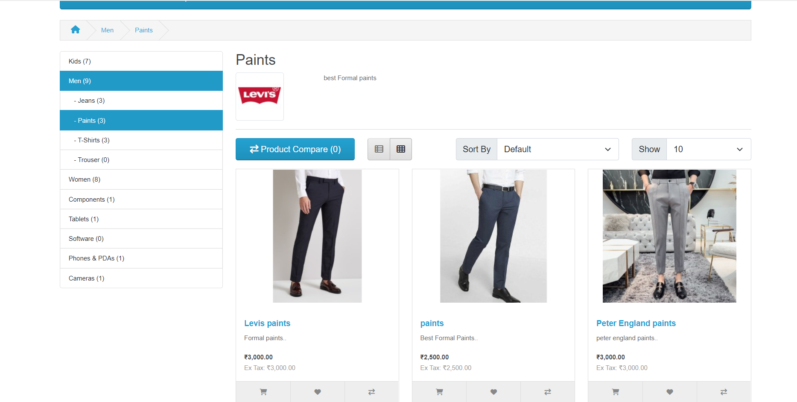

## End User

1. Here now, I am going to discuss regarding the End-user. They just need to register first themselves for shopping from the online portal.
2. For Registration, they must need to fill their basic details like **First Name, Last Name, Email-Id and Password.** After creating account, they can add the address details and later on both options are available.
3. End-user can easily view his Order history, and place an order according to the wish.
4. They can also send the delivery to any other address if they need.
5. For Creating Account, they need to click on the Given link below:

**URL:** <http://fashionstore.appwrk.com/index.php?route=account/register&language=en-gb>

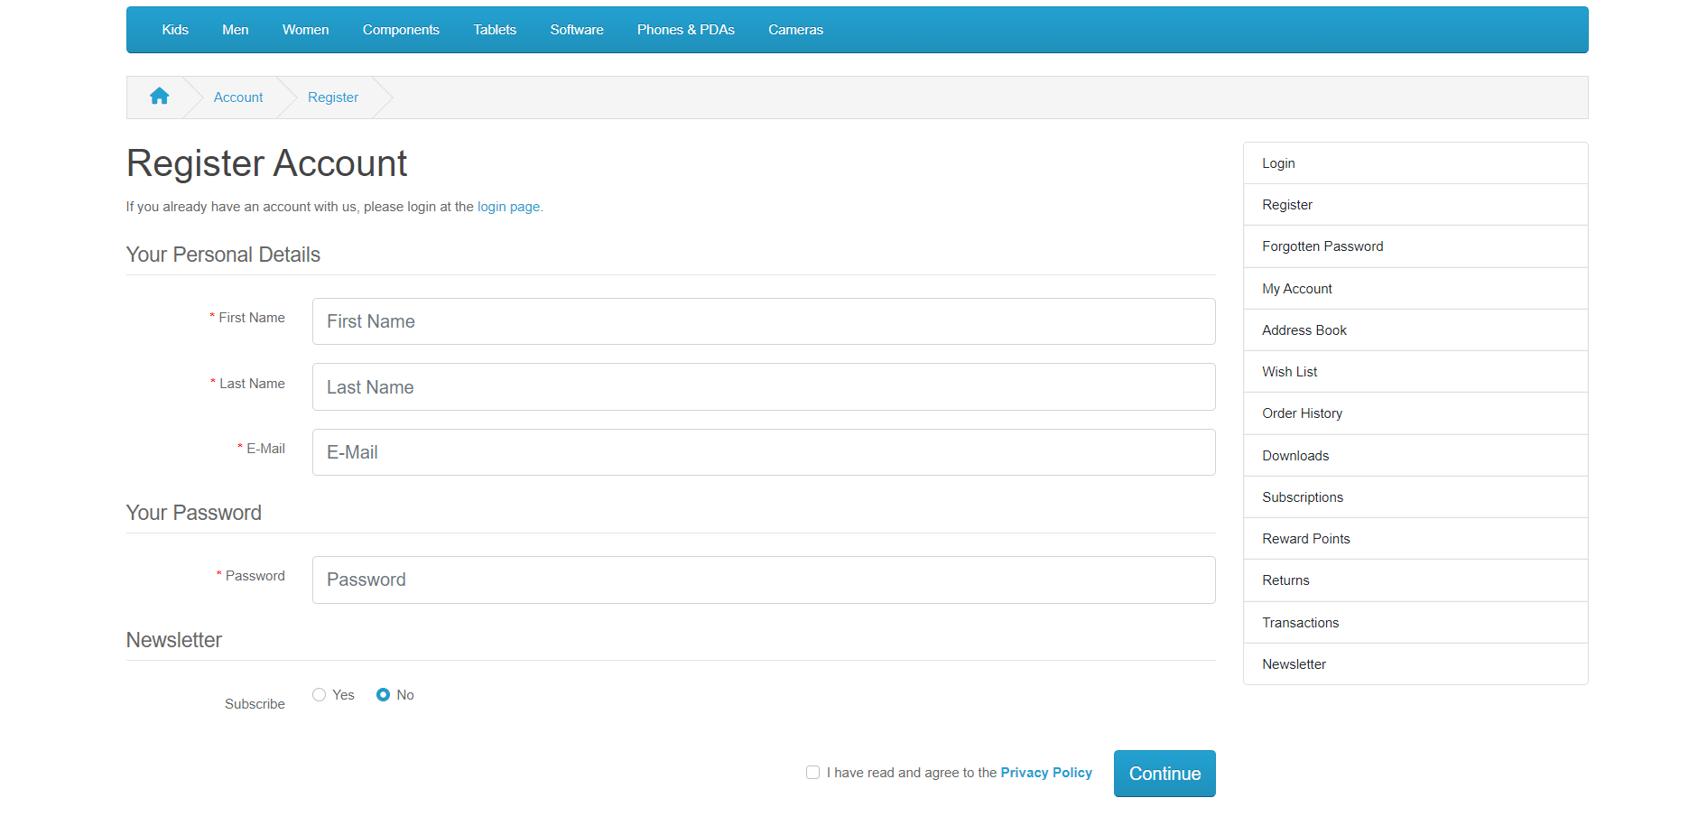

1. After filling the details, then click on the continue button to complete the registration. Then a new will be visible like:

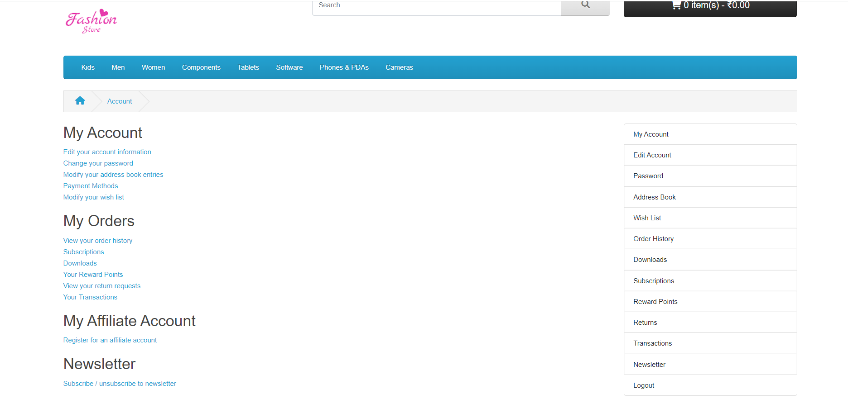

### Customer Login Cred.

1. From the given link the End-user can easily login by filling his registered email-id and Password.

URL: <http://fashionstore.appwrk.com/index.php?route=account/login&language=en-gb>

|  |  |
| --- | --- |
| User Name | Password |
| [Carl80620@gmail.com](mailto:Carl80620@gmail.com) | Password12# |
| [Mohan@gmail.com](mailto:Mohan@gmail.com) | Mohan@#12 |

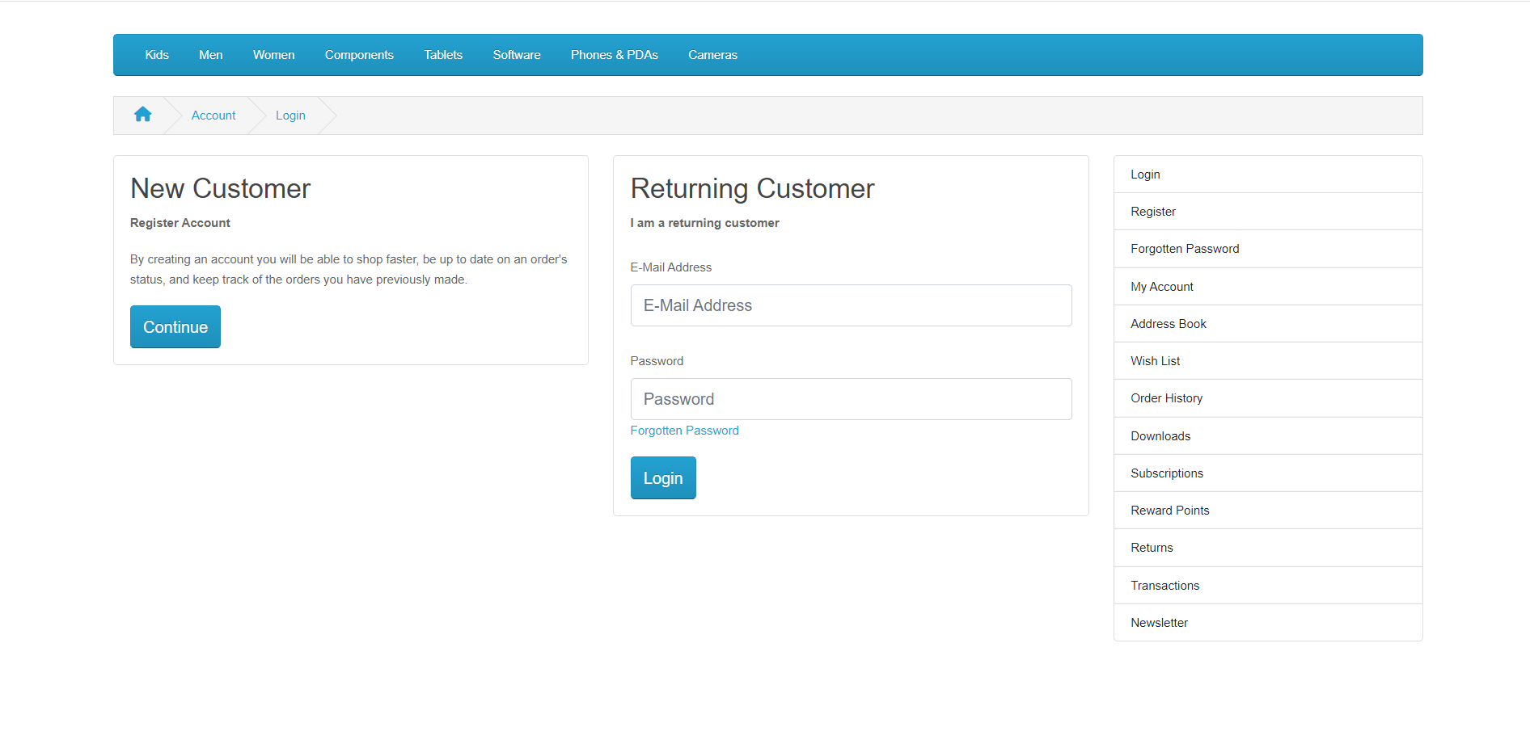

1. After login we will jump to the My Account from where we can view the list of services like Address, Password, Order History, wish list etc.

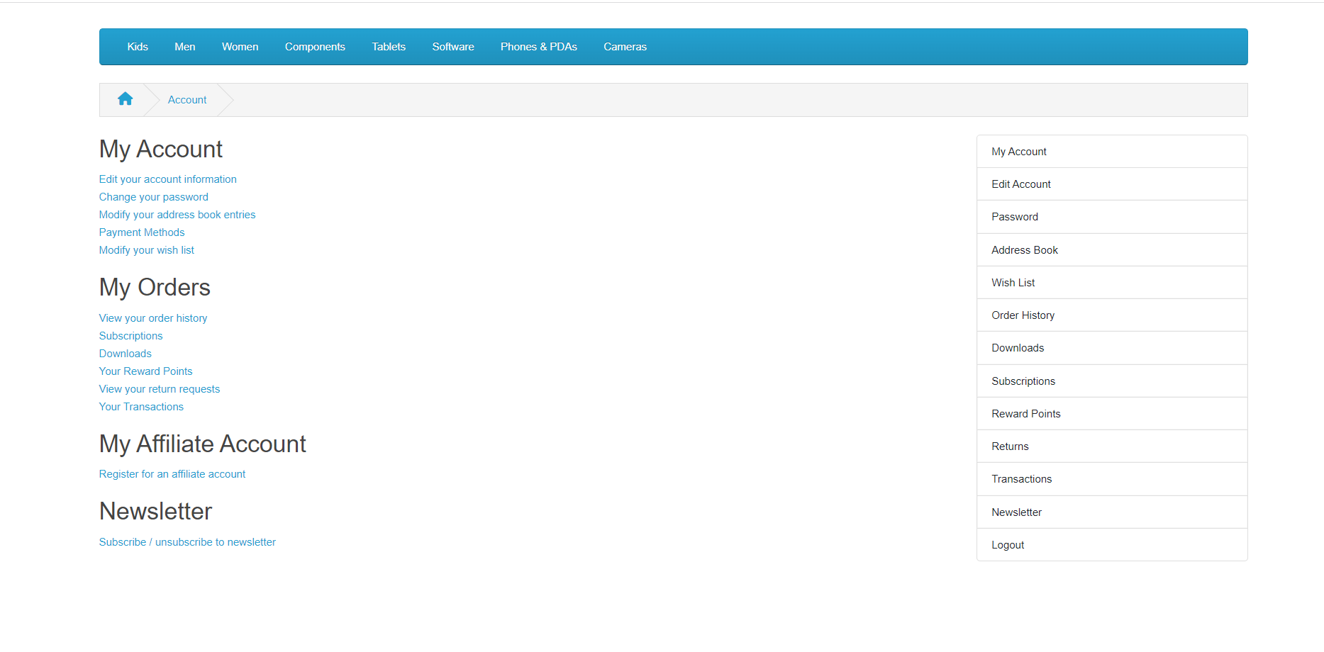

1. After login he can buy anything from the online Fashion Store, he just need to select the product and after checking each details, they need to click on Add to cart to proceed or checkout the order like:

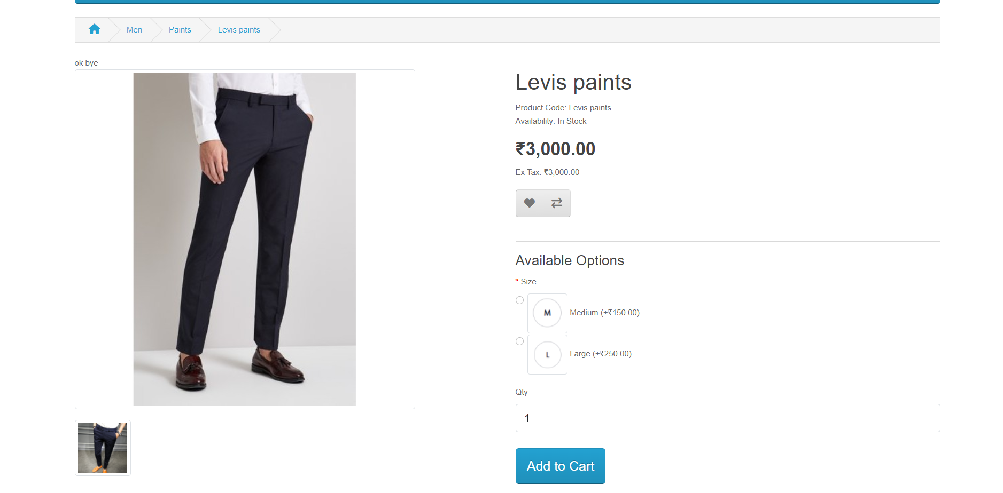

1. After that need to click on the **Add to Cart** and need to **proceed to check out** the process. Then the below section will be visible then need to manage the address for the delivery and click on the next to proceed. They can also give the address of any other location for the parcel according to their wish.

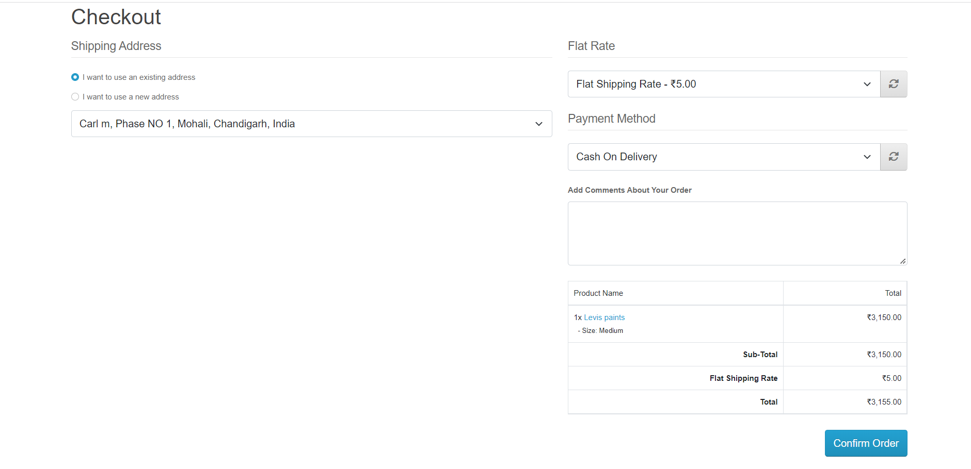

1. Now need to click on the **Confirm Order button** to complete the order for the confirmation page and view that the order has been placed.

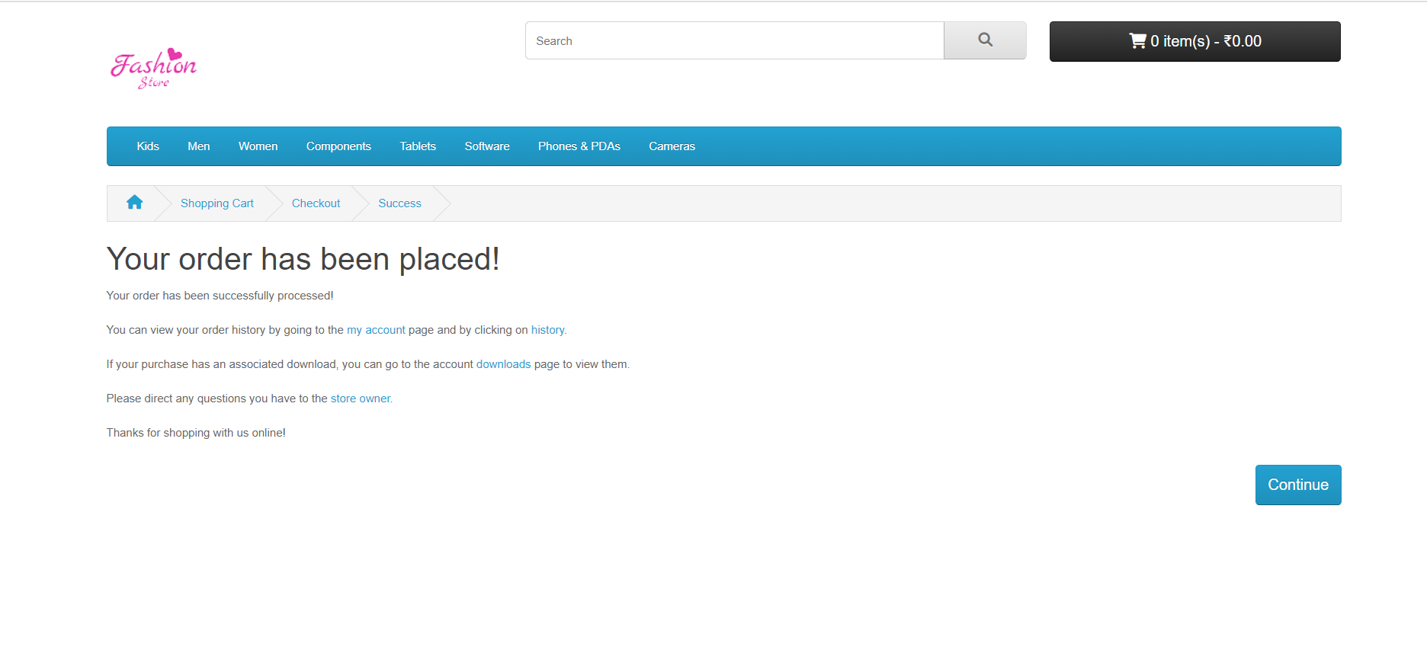

1. For the verification process, here we can click on the **order history** from **my Account** section and also can check the status of the order.

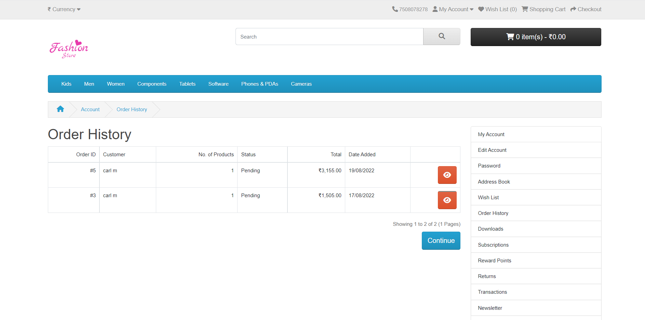

# **List of Steps and Technology stack used**

## Step 1: Install PHP

* PHP 8.1
* MySQL 8.0
* Apache

**Link to Download:** [Download XAMPP (apachefriends.org)](https://www.apachefriends.org/download.html)

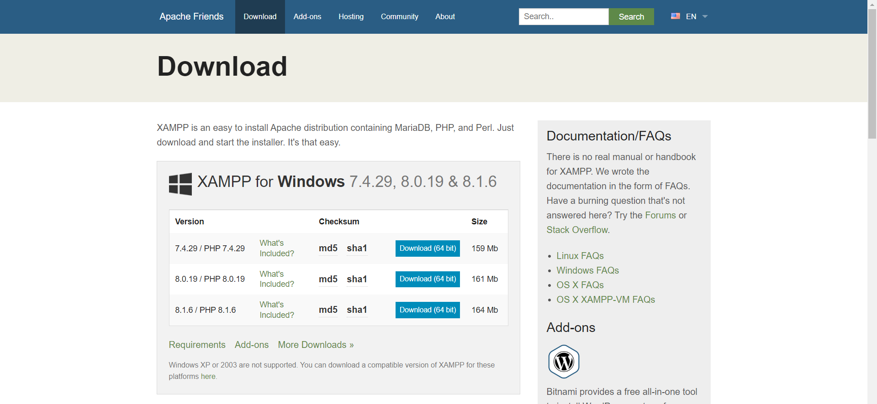

After downloading the Software just need to double Click on the Exe file to install into the System. After that a New Windows will be appear in which we just need to select the list of components to be installed with the PHP version like:

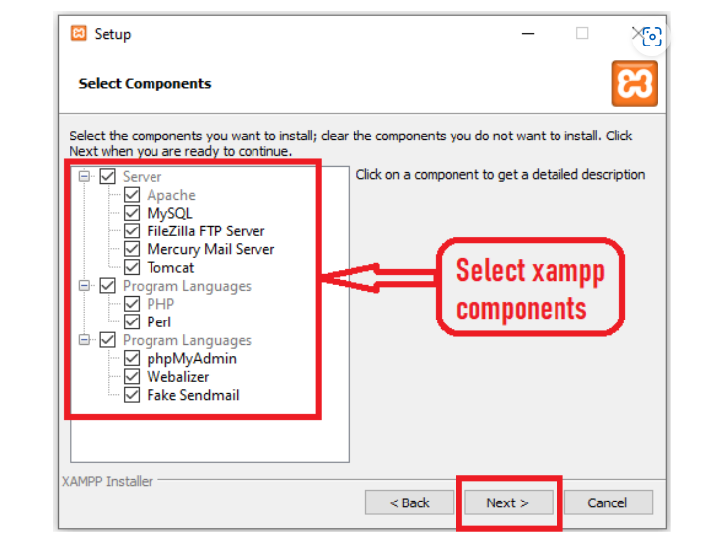

After that we just need to select the location of the **PHP folder** where we have installed PHP like in Drive of the System whatever it is **D drive or any other drive**. Then we just need to click on Next, Next and finish. I have installed PHP in **D Drive Xamp8.1** with the name of the Folder.

When our PHP and MySQL is Completely Installed on the System, then the **XAMP Control Panel** will be visible in front of the Screen from where we can **start or stop the Local Server.**

Here we can see the Highlighter field which can be used for the working for start and stop the server. We can also see the version of the Apache, MySQL with the Port Number.

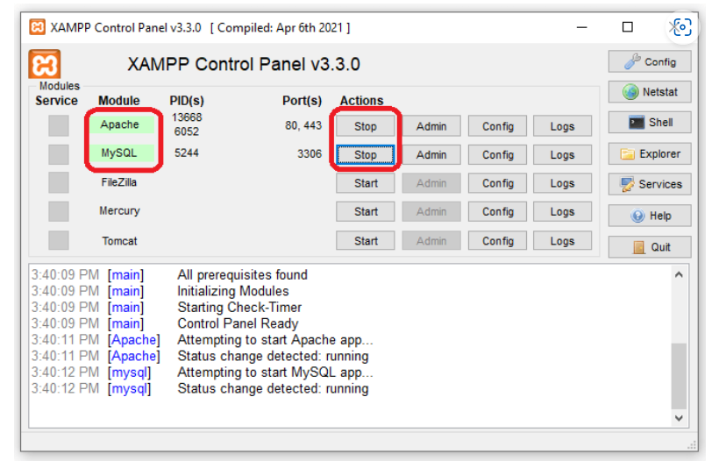

## Step 2: Download Opencart4.0.0

After the installation of PHP now need to **download the OpenCart4.0.0.** from the Website and need to copy paste into the **Htdocs of the XAMP8.1**

**Download Link:** <https://www.opencart.com/index.php?route=cms/download>

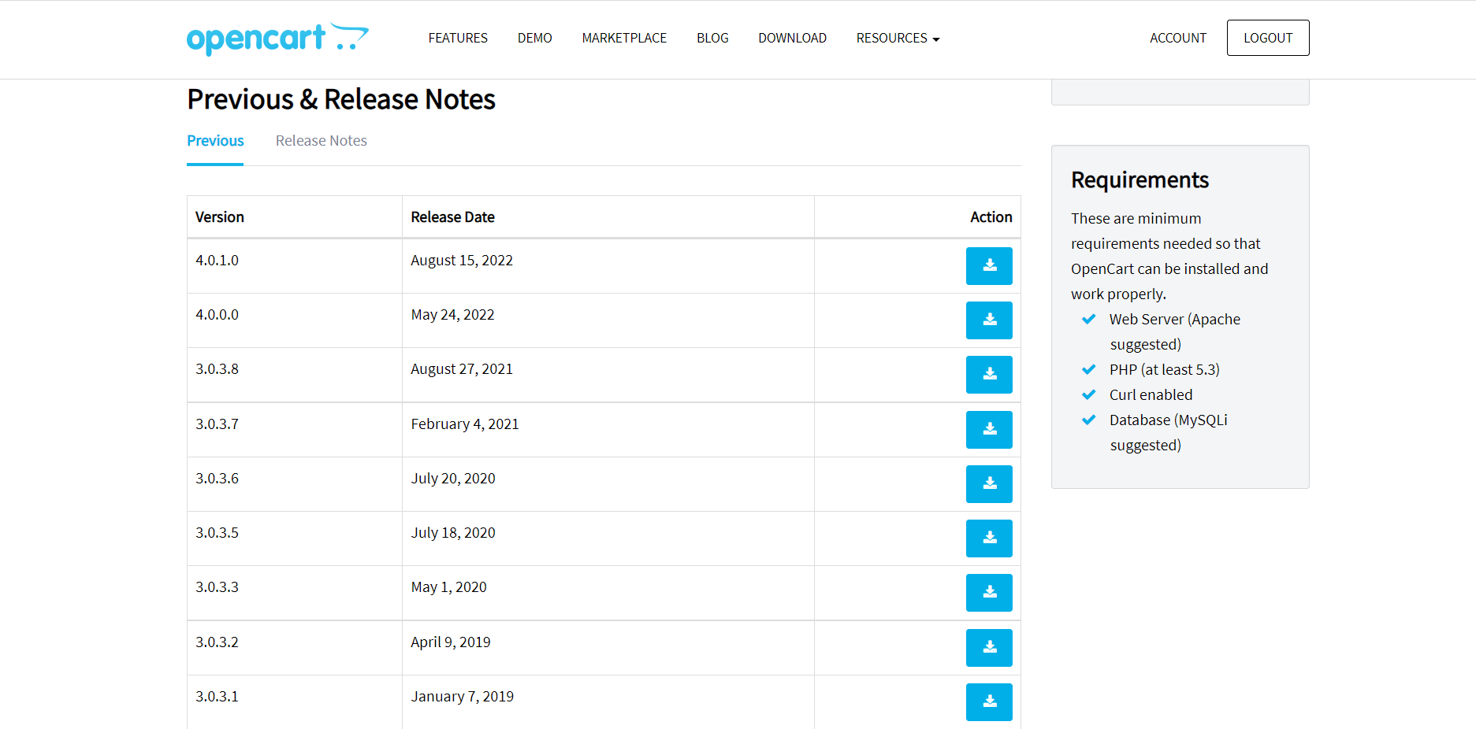

After downloading, we need to unzip the folder into the **D: Xampp8.1\htdocs** folder of the **D:\Drive**

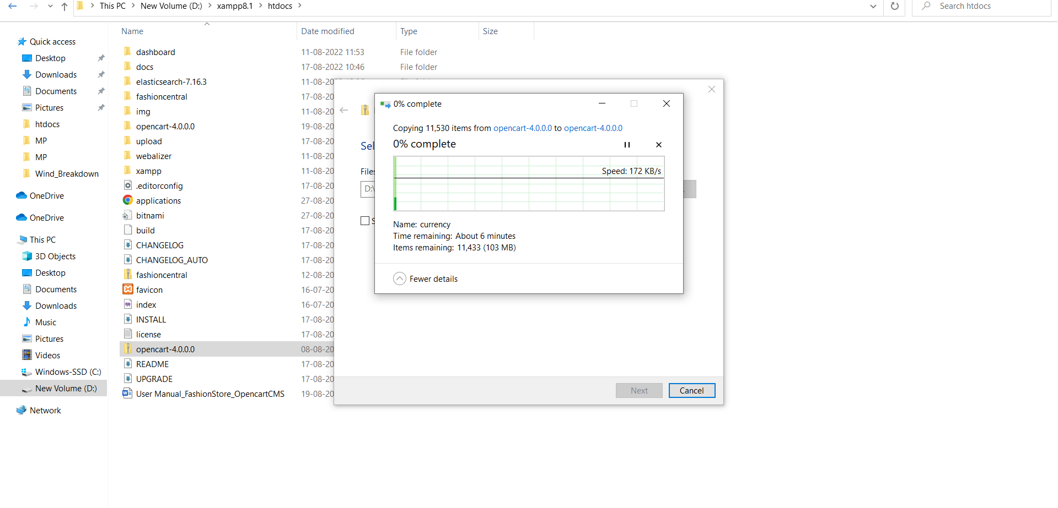

After that, need to go to the **MySQL** from **PhpMyAdmin** for creating the database for the **backend Server** we can create with any name. for this we need to click on the Admin from the Control Panel of the Xampp.

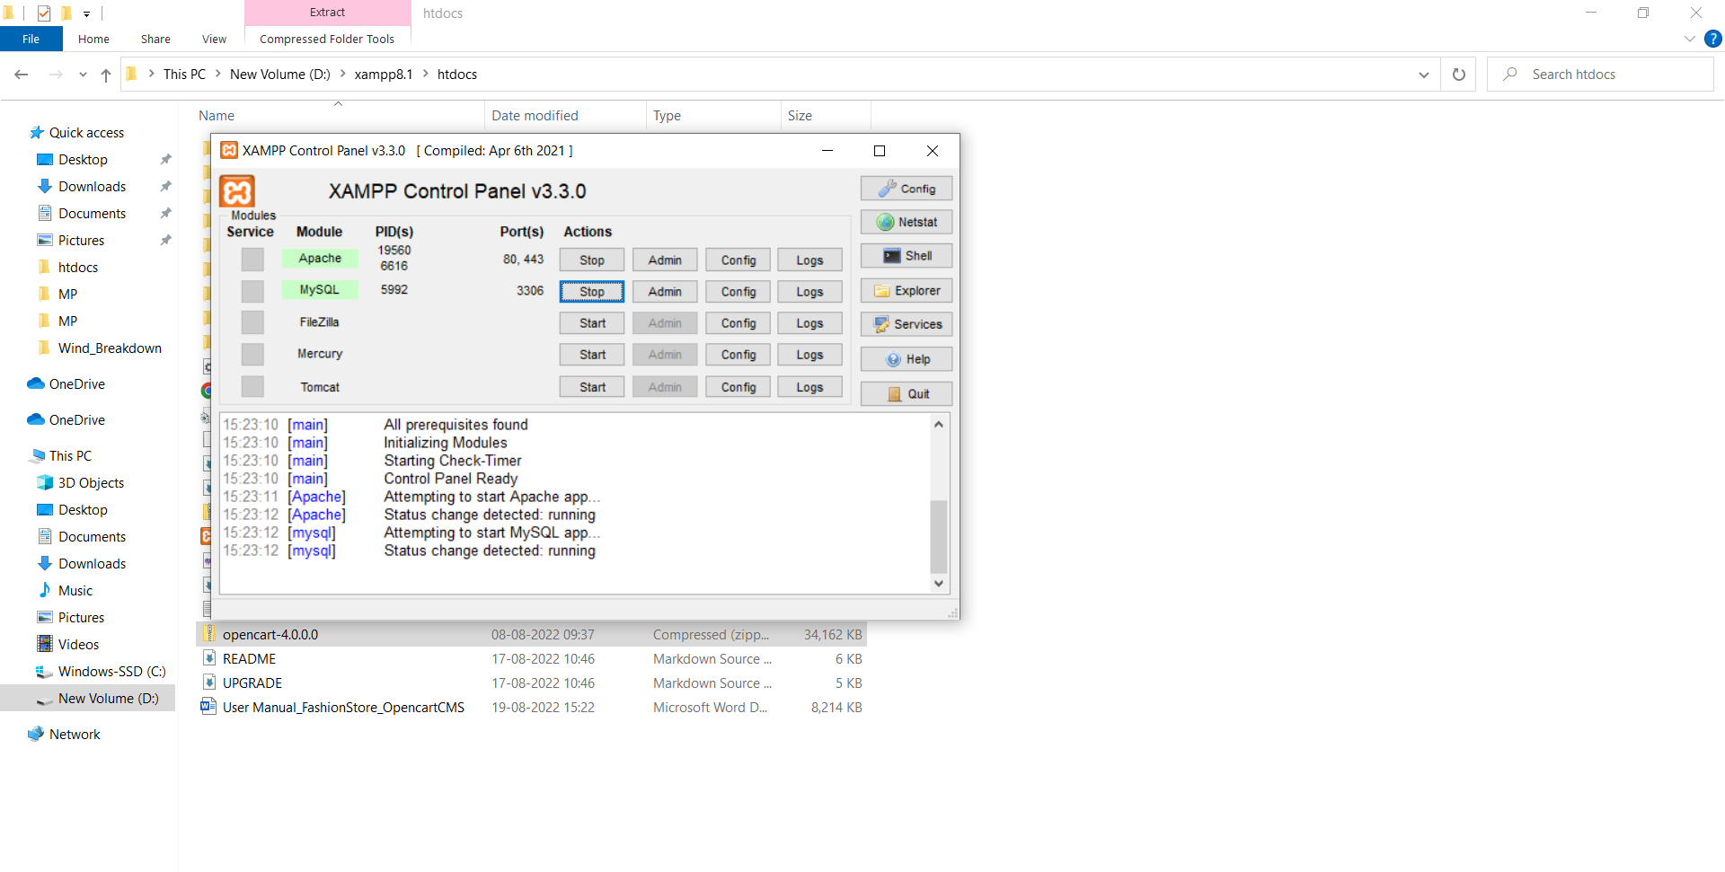

Now we need to create a New Database with the help of the PhpMyAdmin area. Here I have created the database with the Name of **fashionStore** then need to click on the Create button.

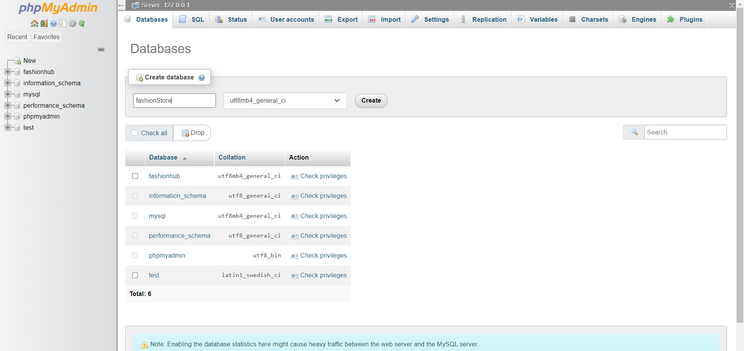

## Step 3: Installation of the OpenCart into Xampp

After moving the folder into the **htdocs** here we need to copy the data from the **upload** folder to the **root directory** so thus we can easily manage the admin and control panel of the Store.

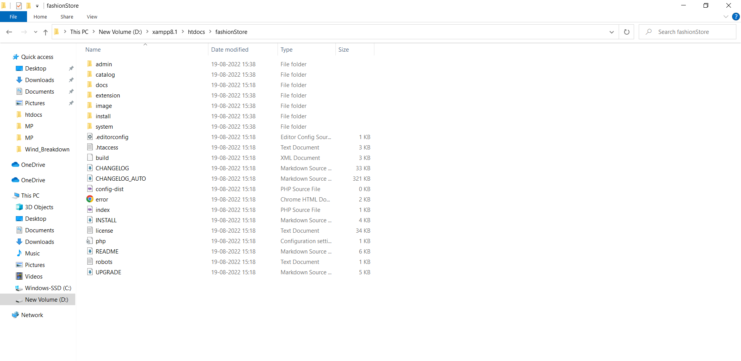

After that need to go to the browser to check the URL for this we need to type the **“Localhost/fashionStore/”** in the **URL**

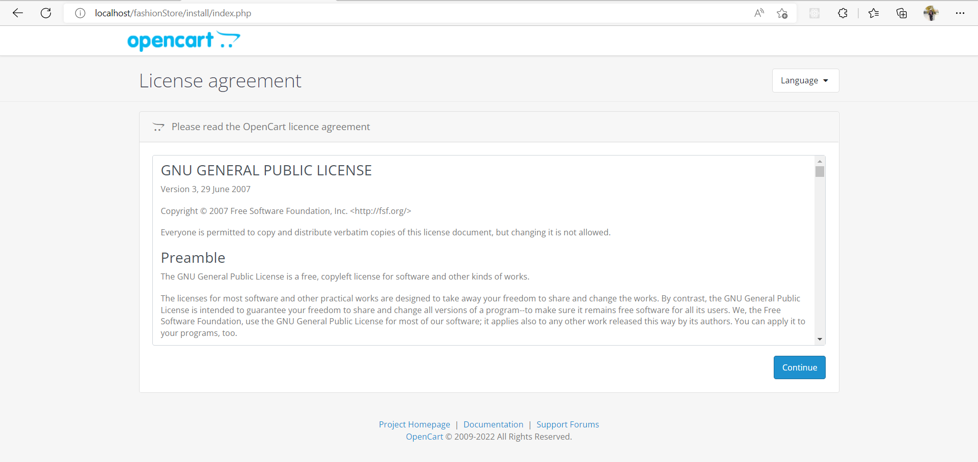

Now need to click on the Continue for the further setting and configuration. Here we need to check the list of Extensions are enable or not into the **PHP Control Panel**.

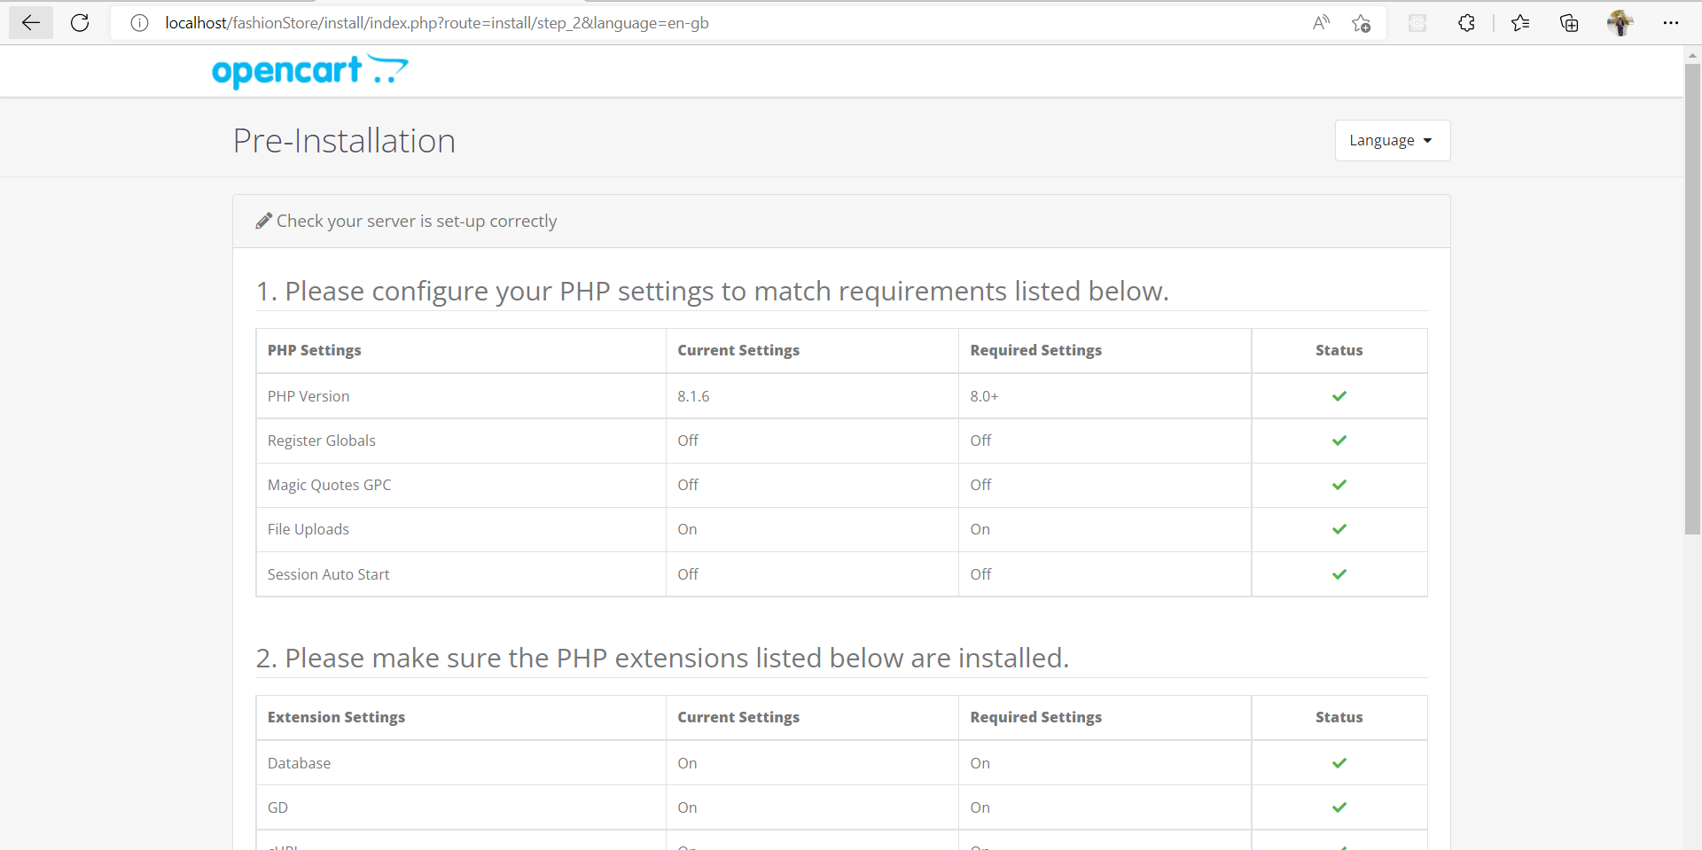

After that we need rename the config file form the **root directory** and **admin directory** which is default **config-dist.php** to **config.php,** after that we can see that the error related to the file has been resolved.

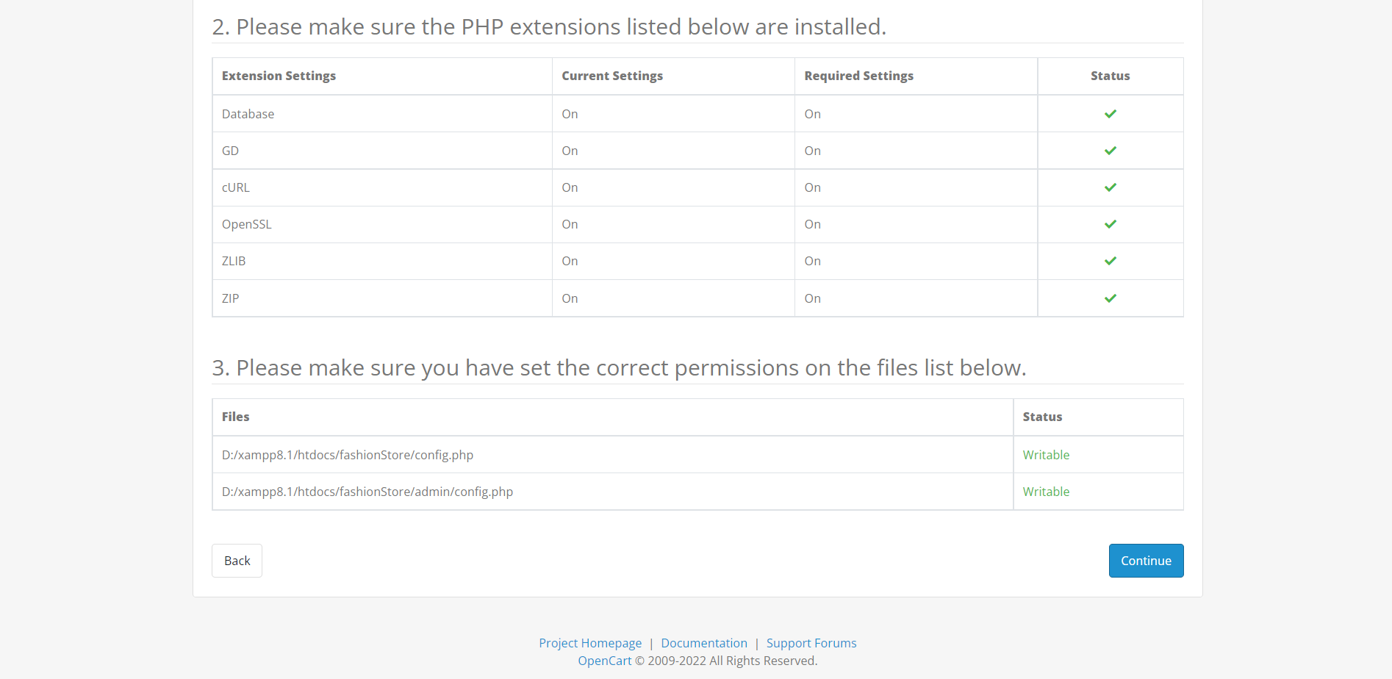

Now need to click on continue to proceed for the further process which needs related to the network configuration process like name of the **database, user name and password** of the admin for the **OpenCart** portal.

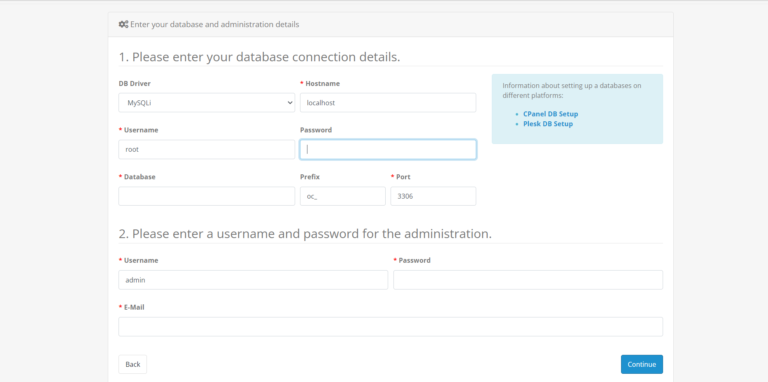

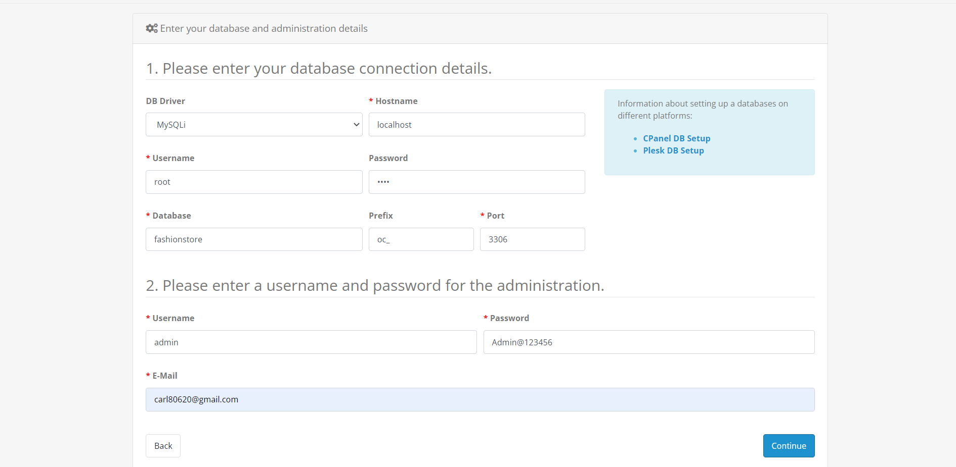

After that need to click on the continue to proceed. Here we can check that the OpenCart has been properly installed over the server.

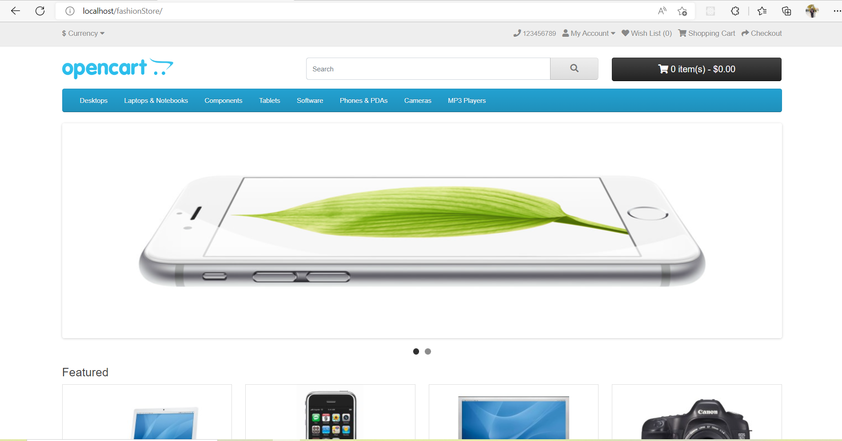

FashionStore also has two different panel like admin and local both has different view like:

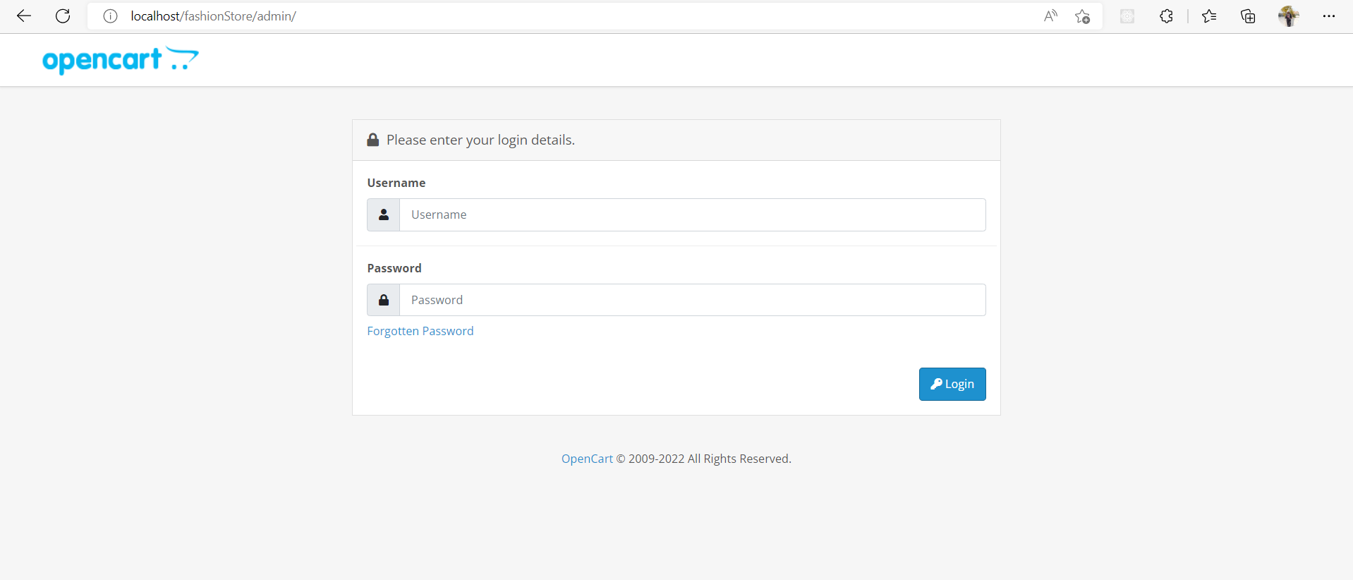

# **Things to remember after OpenCart theme installation**

When I have installed, OpenCart for the configuration when I have opened the Store at the Localhost then I got this error which is the configuration related to solve this error. Without these files we are not be able to store the details of the store like database name, user name and password etc.

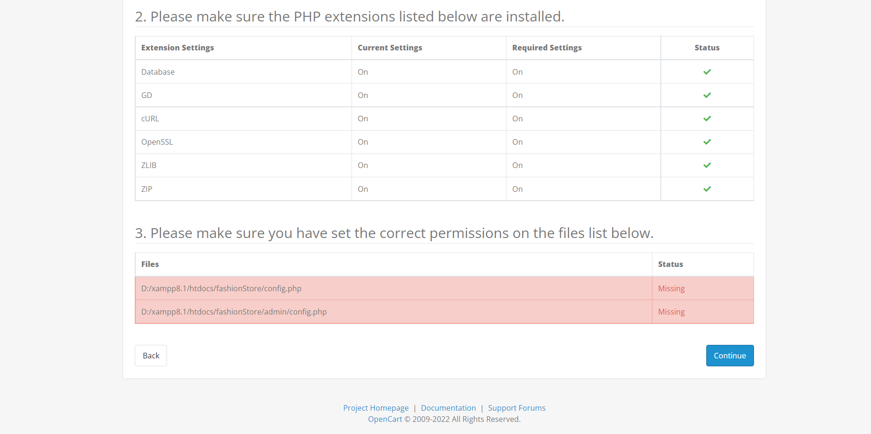

Then need to get the help of the command to fix this bug:

I need to rename the file name from the root Directory and Admin Directory from the OpenCart Store. Then the bug will be resolved, by default the name of the file would be **config-dist.php** then need to rename with the Name of **Config.php** from the both of directory.

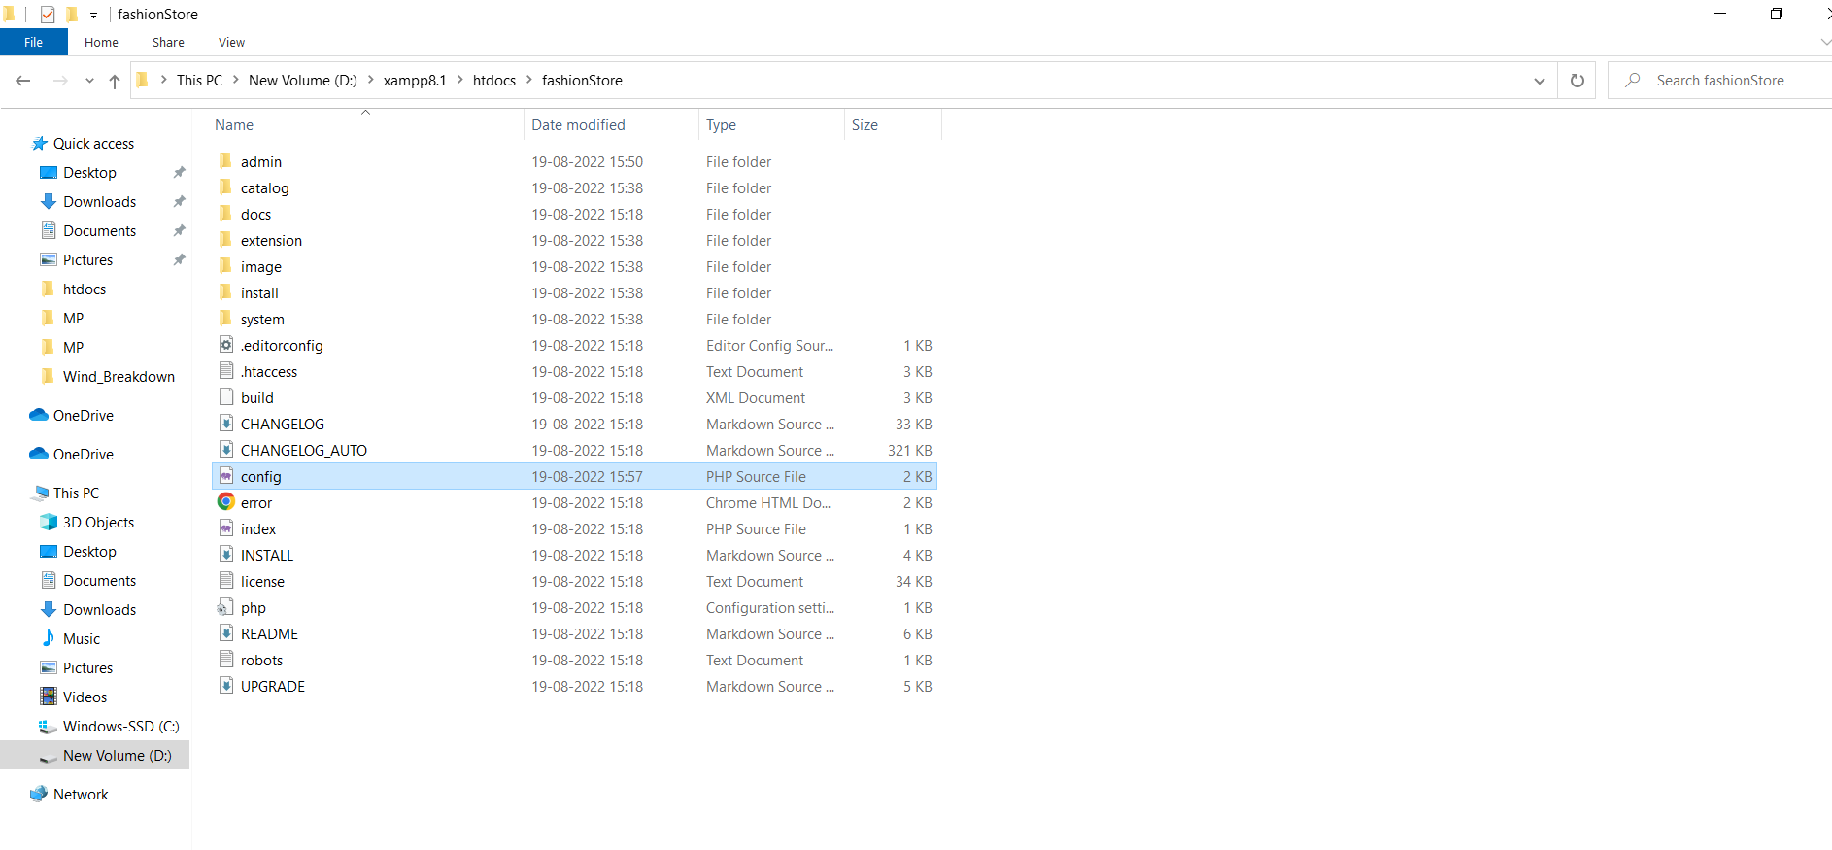

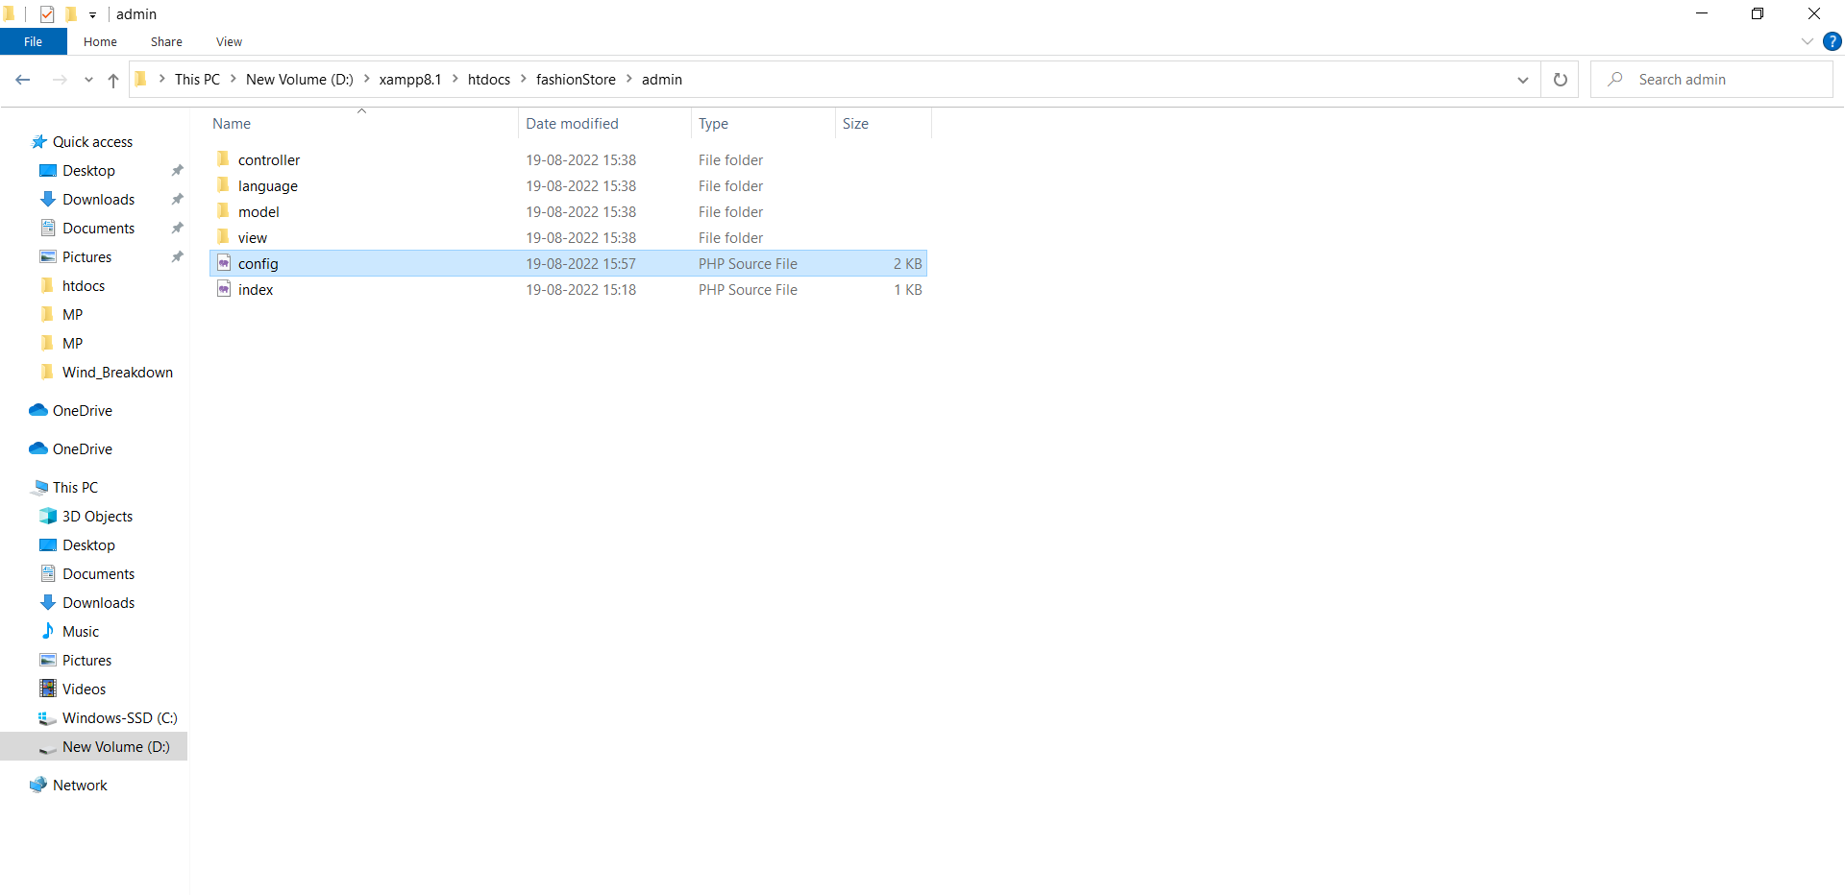

Here we can check that now the bug related to the files has been resolved.



------------------------------ END OF THE DOCUMENT --------------------------